|  |  |  |  |  |
| --- | --- | --- | --- | --- |
| **PENGAJUAN DANA** | | | | |
| **No** | **Nama Barang** | **Banyak** | **Harga** | **Total** |
| 1 | IMAX B6AC V2 80W CHARGER DISCHARGE BATERAI AC ADAPTER LIPO RC ORIGINAL | 1 | Rp274.000 | Rp274.000 |
| 2 | JGA25-12CPR 1:34 Motor DC Gearbox Magnetic Encoder | 4 | Rp180.000 | Rp720.000 |
| 3 | Lipo Battery 3s 11.1v 5200mah 80-160c Onbo Power | 2 | Rp999.000 | Rp999.000 |
| 4 | Hub omni/mekanum wheel 100mm,127mm,150mm | 1 | Rp111.000 | Rp111.000 |
| 5 | Motor DC PG45 500Rpm 25kgfcm 60W 200PPR encoder | 1 | Rp1.200.000 | Rp1.200.000 |
| 6 | Dudukan PG45 | 1 | Rp 55.500 | Rp 55.500 |
| 7 | Akrilik 5mm | 1 | Rp300.000 | Rp300.000 |
| 8 | Roda Omni Metal 58MM Omniwheel Omnidirectional Wheel Alumunium | 4 | Rp200.000 | Rp800.000 |
| 9 | Braket Dudukan Motor Dinamo 370 380 385 390 395 Reducer | 4 | Rp22.000 | Rp88.000 |
| **Total Biaya** | | | | **Rp4.547.500** |

**LAMPIRAN**

1. IMAX B6AC V2 80W CHARGER DISCHARGE BATERAI AC ADAPTER LIPO RC ORIGINAL

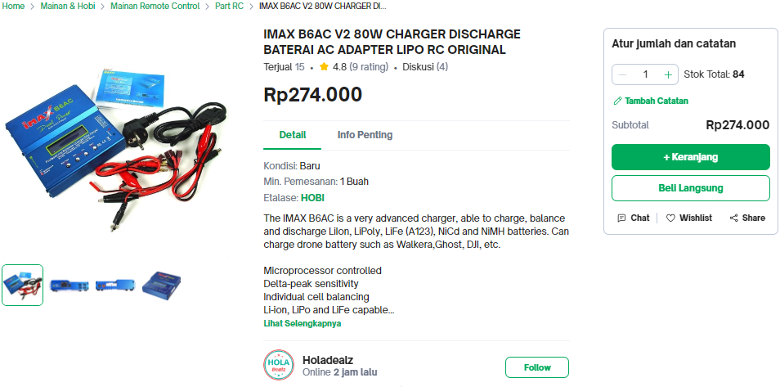

1. JGA25-12CPR 1:34 Motor DC Gearbox Magnetic Encoder

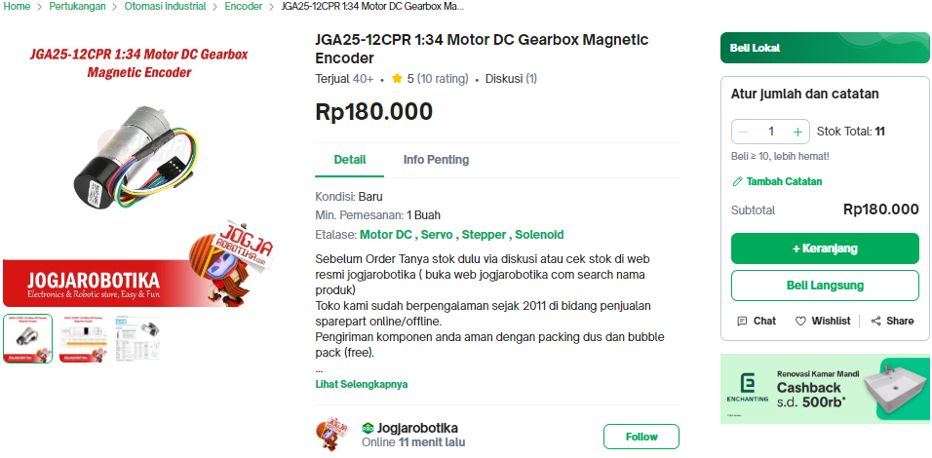

1. Lipo Battery 3s 11.1v 5200mah 80-160c Onbo Power

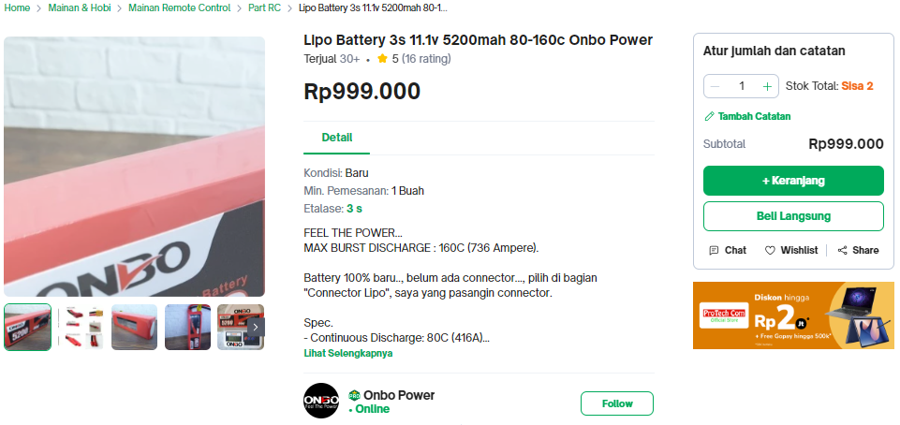

1. Hub omni/mekanum wheel 100mm,127mm,150mm

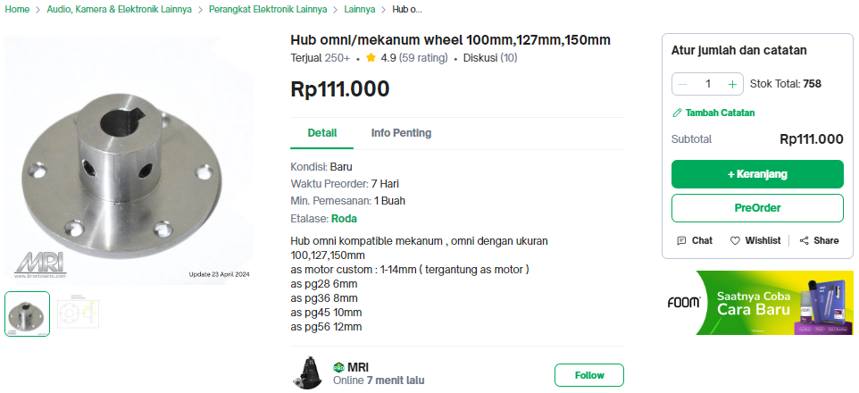

1. Motor DC PG45 500Rpm 25kgfcm 60W 200PPR encoder

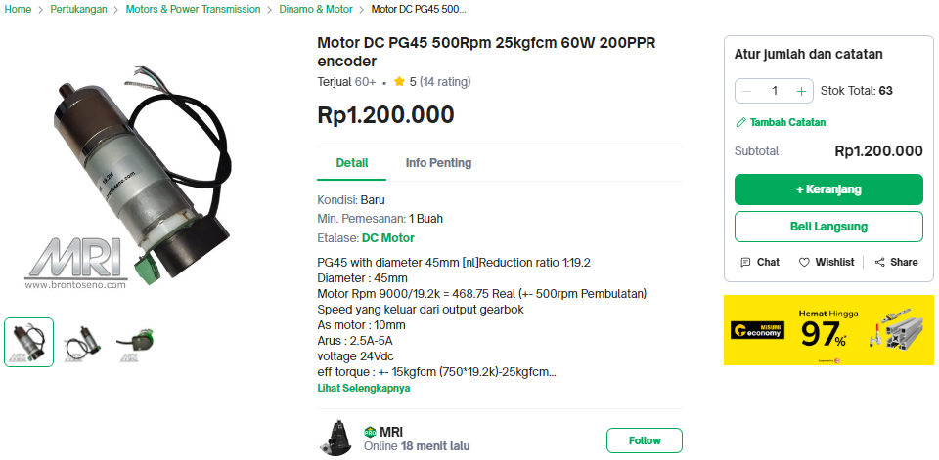

1. Dudukan PG45

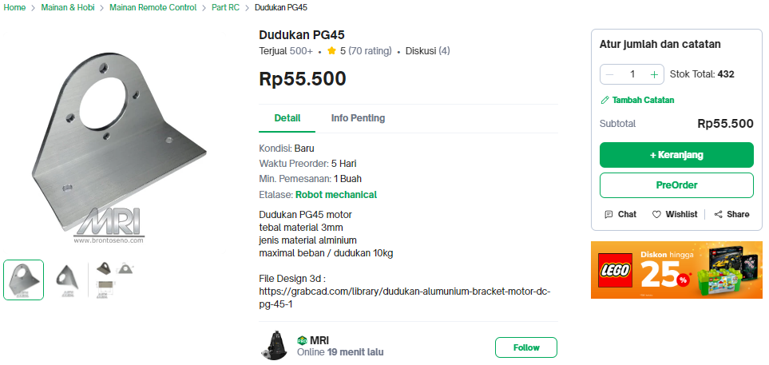

1. Akrilik 5mm (OFFLINE)
2. Roda Omni Metal 58MM Omniwheel Omnidirectional Wheel Alumunium

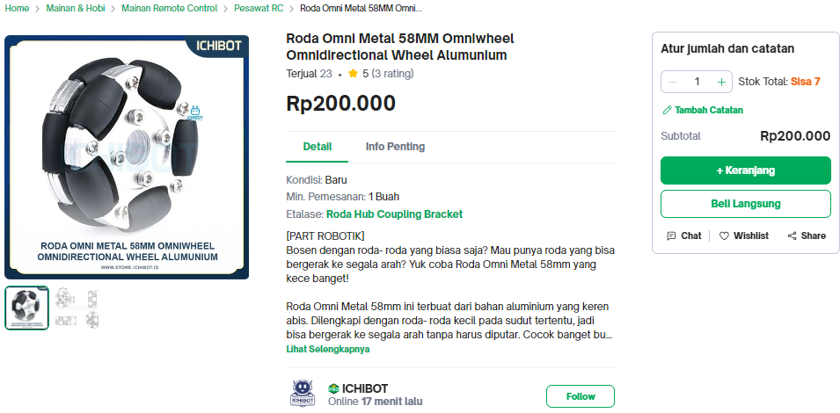

1. Braket Dudukan Motor Dinamo 370 380 385 390 395 Reducer

